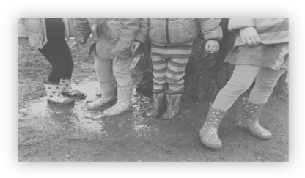

The Ames Child Care Center (ACCC) is a non-profit childcare center and preschool located at the NASA Ames Research Center at Moffett Field. The ACCC is accredited by the prestigious NAEYC. The ACCC serves families employed at NASA Ames Research Center and the surrounding community. The tuition paid by the parents covers salaries and operational costs only. All other costs, such as playground improvements, tuition assistance, and staff appreciation, are covered by fundraising activities such as the ACCC Golf Tournament. The ACCC is currently raising funds to support our Tuition Assistance Council, preschool shade structures, and facility upgrades.

Tournament Format
The tournament format will be a four-person scramble (best shot from your team used for each stroke). Detailed rules will be provided on the day of the tournament.

Sponsorship Packages
Most of the proceeds from our golf tournaments have come from the generous contributions of corporate sponsors. Please join our list of donors by supporting the tournament through one of the sponsorship programs described below, or by donating a raffle prize or sponsor-logo golf item (e.g., golf balls, tees, towels, etc.).
Golf package includes practice balls for the driving range, a round of golf, 2-person electric cart, beverages, and lunch .
Eagle Sponsor $750
Four entries, signage on tournament banner, tee box sign, and acknowledgement in tournament brochure.
Birdie Sponsor $500
Two entries, tee box sign, and acknowledgement in tournament brochure.

Par Sponsor $250
One entry and acknowledgement in tournament brochure.

Sponsor Registration

Yes! I want to sponsor the Ames Child Care Center Golf Tournament at the following level:
- Eagle Sponsor: $750
- Birdie Sponsor: $500
- Par Sponsor: $250
Team Name:

Golfers’ Names:
(Sponsors only)

Contact Information:
Name:
Company:
Address:
City/State /Zip:
Phone:
E-mail address:

Check here if you have an electronic version of your company logo. Our tournament organizers will contact you to receive the logo.
Raffle Prize Donations
Raffle prize donations can be gift certificates, merchandise, or cash. Donors will be recognized at the raffle drawing and in the Tournament Program Brochure.
- Cash
Amount:
- Gift Certificate
Amount:
Description:
- Merchandise or Other
Description:

Company Name:
Contact Name:
Phone Number:
E-mail Address:

Please make checks payable to ACCC and send this form with payment by July 23, 2018 to:

ACCC Golf Tournament

NASA Ames Research Center

Bldg N270 / MS 270-1

Moffett Field, CA 94035-0001

All donations minus greens fees may be tax deductible. Contact the ACCC for more information.

For more information on sponsoring the ACCC Golf Tournament, please contact Sean Winther (650-604-6091, Sean.W.Winther@nasa.gov)
For more information on the ACCC,
visit http://www.ameschildcare.org/

Team Registration
Fee per player includes practice balls for the driving range, a round of golf, 2-person electric cart, beverages, and lunch .
Number of players: |  | Total Fees:
 | x $80 each | $

Team Name:

Golfers’ Names:

Contact Information:
Team Captain:
Address:
City/State / Zip:
Phone:
E-mail:

*The Golf Club at Moffett Field rules require electric carts for tournament players.

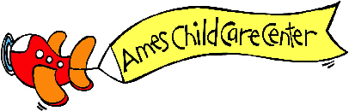

Celebrating 30 years of caring for young children

Ames Child Care Center

Golf Tournament


Registration and Drawing Prize Donation Form

Friday, July 27, 2018
Registration – 8:00 AM
Shotgun Start – 9:00AM
Lunch and Drawing Prizes – 3:00 PM

The Golf Club at Moffett Field
Moffett Field, CA

